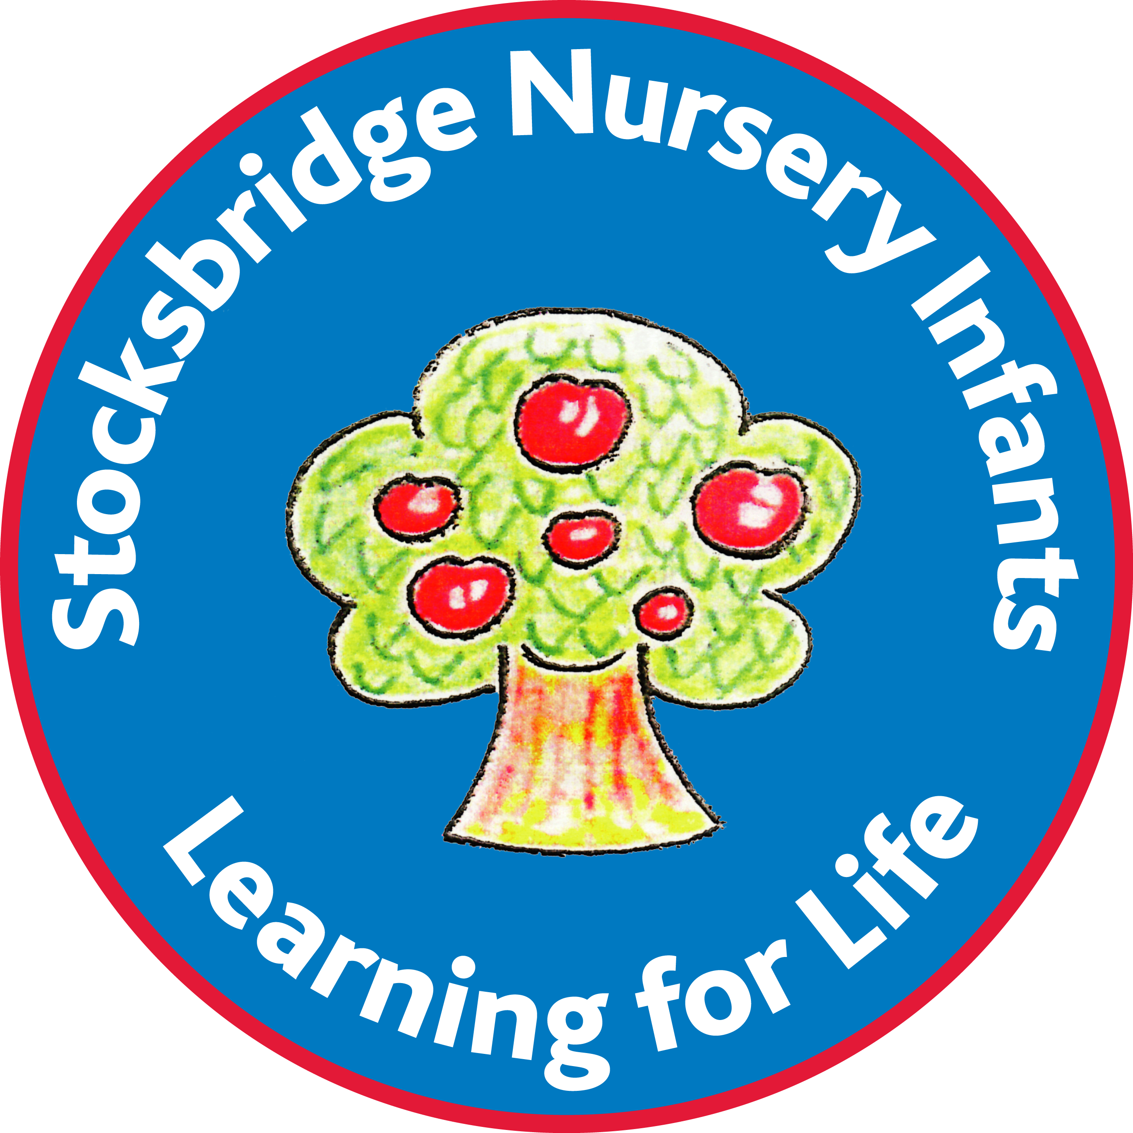
Stocksbridge Nursery Infant School - Pot House Lane - Sheffield - S36 1EJ
Telephone – 0114 2883109

13.9.19

Dear Parents/Carers,

A very warm welcome to you all. We hope you’ve all had a fantastic summer and are looking forward to starting this new school year.

Here is a taster of what will happen on a regular basis in class 8.

Routine of the morning:

- First of all, help your child to find their peg and hang up their coat.
. 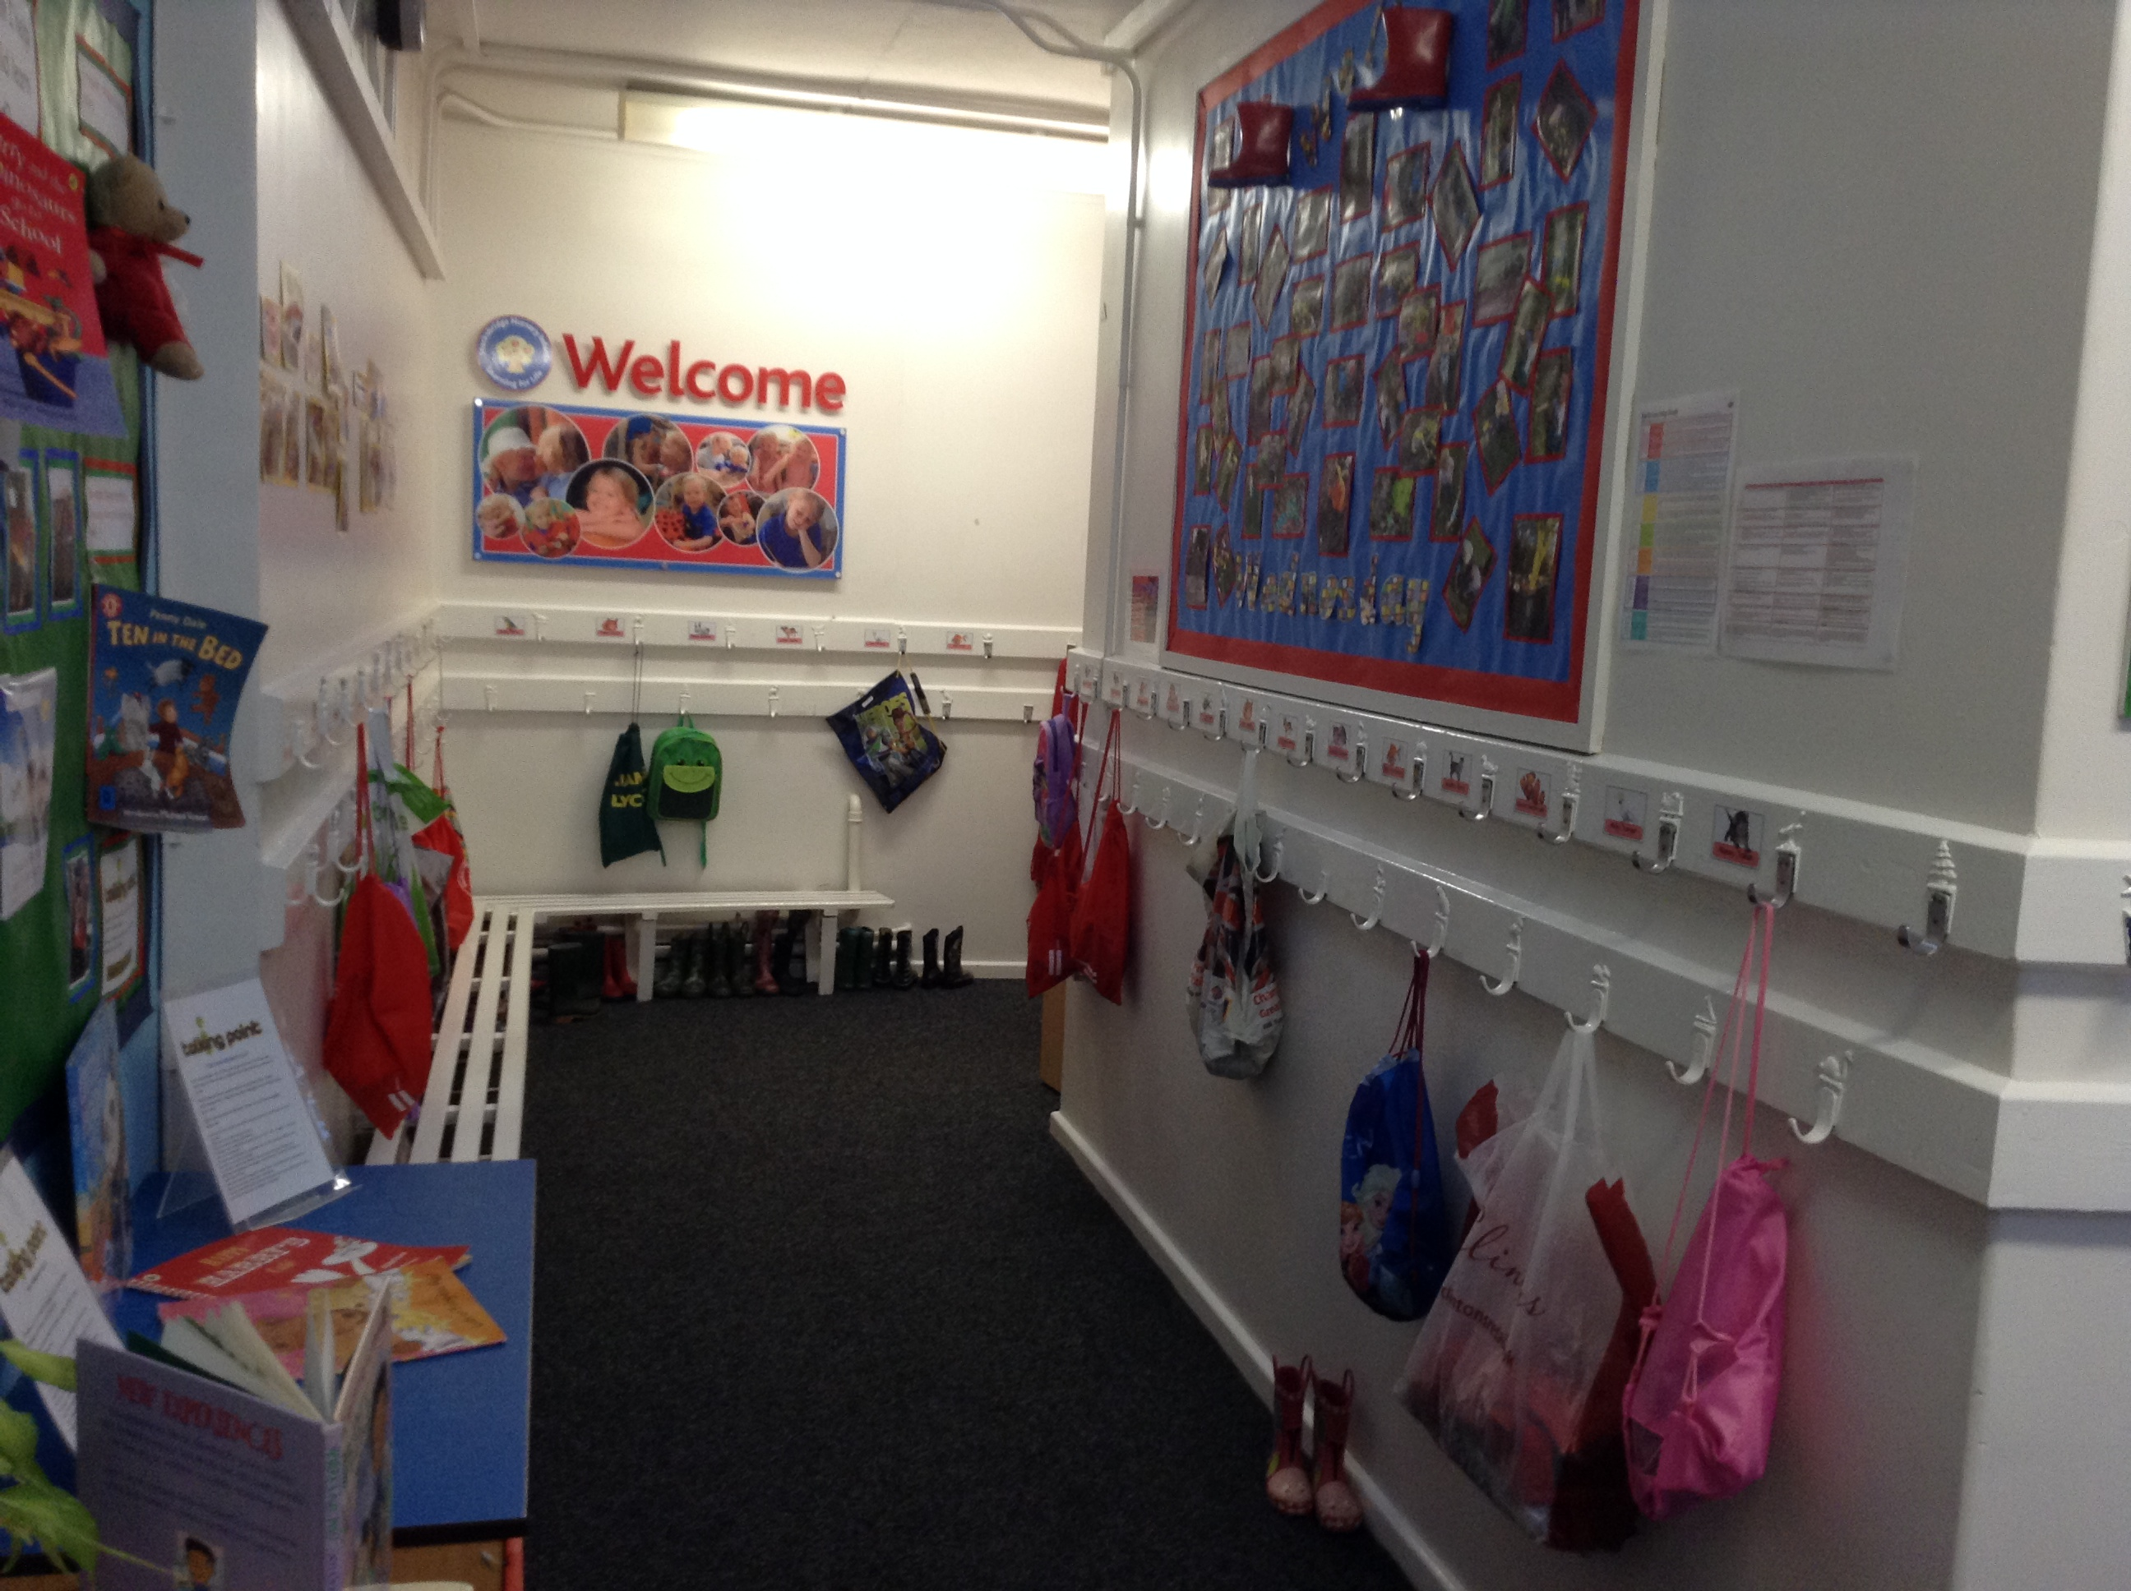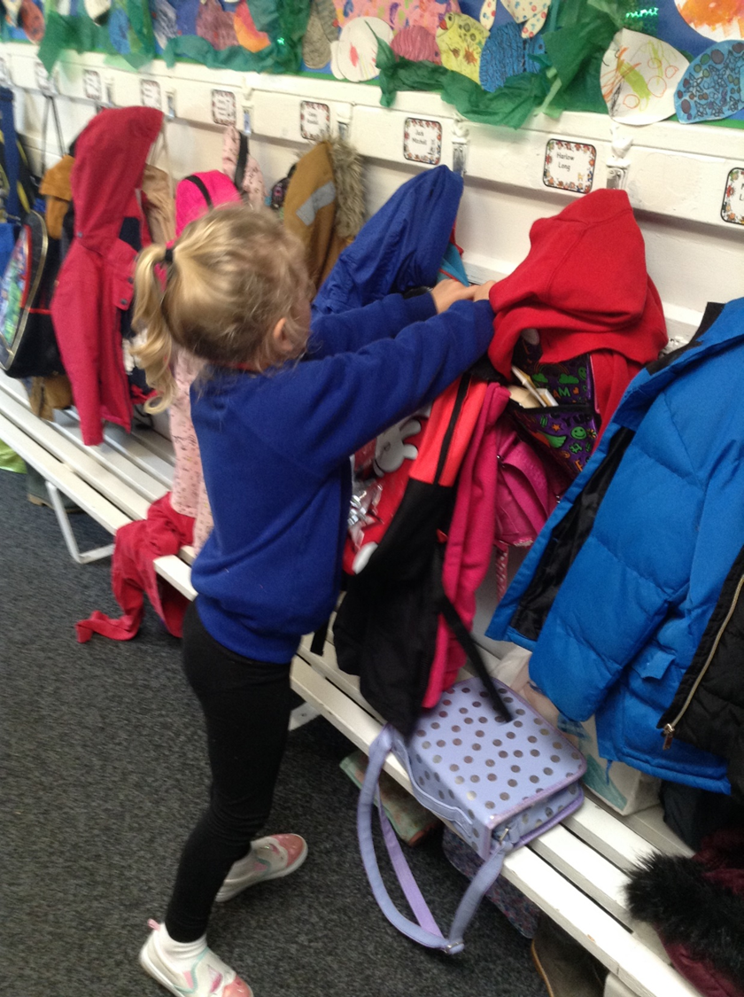

- Put your book bag and PE bag on the peg underneath your coat.

- Should your child bring a packed lunch from home, please pop it on the blue trolley in the school hall.

- Put your named water bottle in the blue water tray next to the sink.

- Put your healthy snack from home in the red baskets in the centre of the classroom next to our snack table.
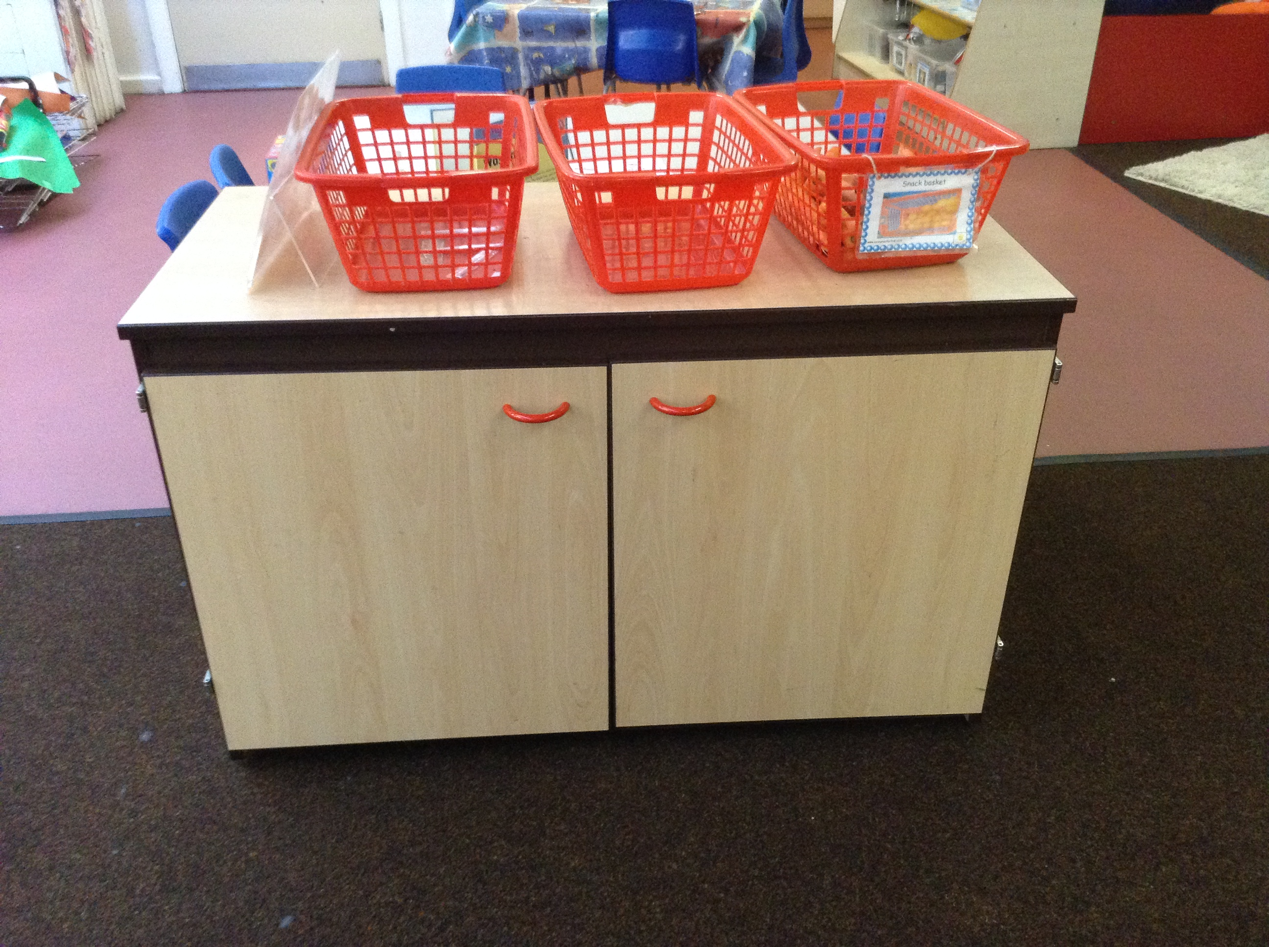

- Now please make a choice from the lunch menu on the smart board and help your child to decide on their lunch choice.

- Now that all of our children have started school we’d like them to first practise writing their name using the laminated cards we have in class. After that you are free to choose a book from around the room and share this with your child. Have fun looking at the pictures and talking about what you can see. Please return the book to its home when you have finished and select another one. There are plenty of different books to suit all tastes. If you can’t find anything suitable, just let us know and we’ll give you a hand or find something new.
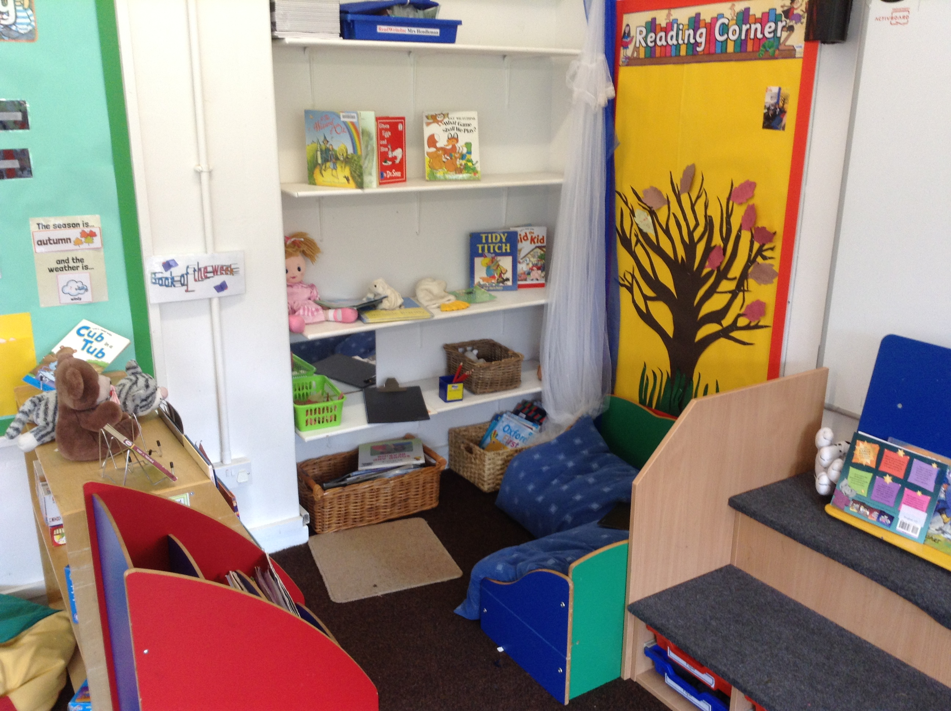
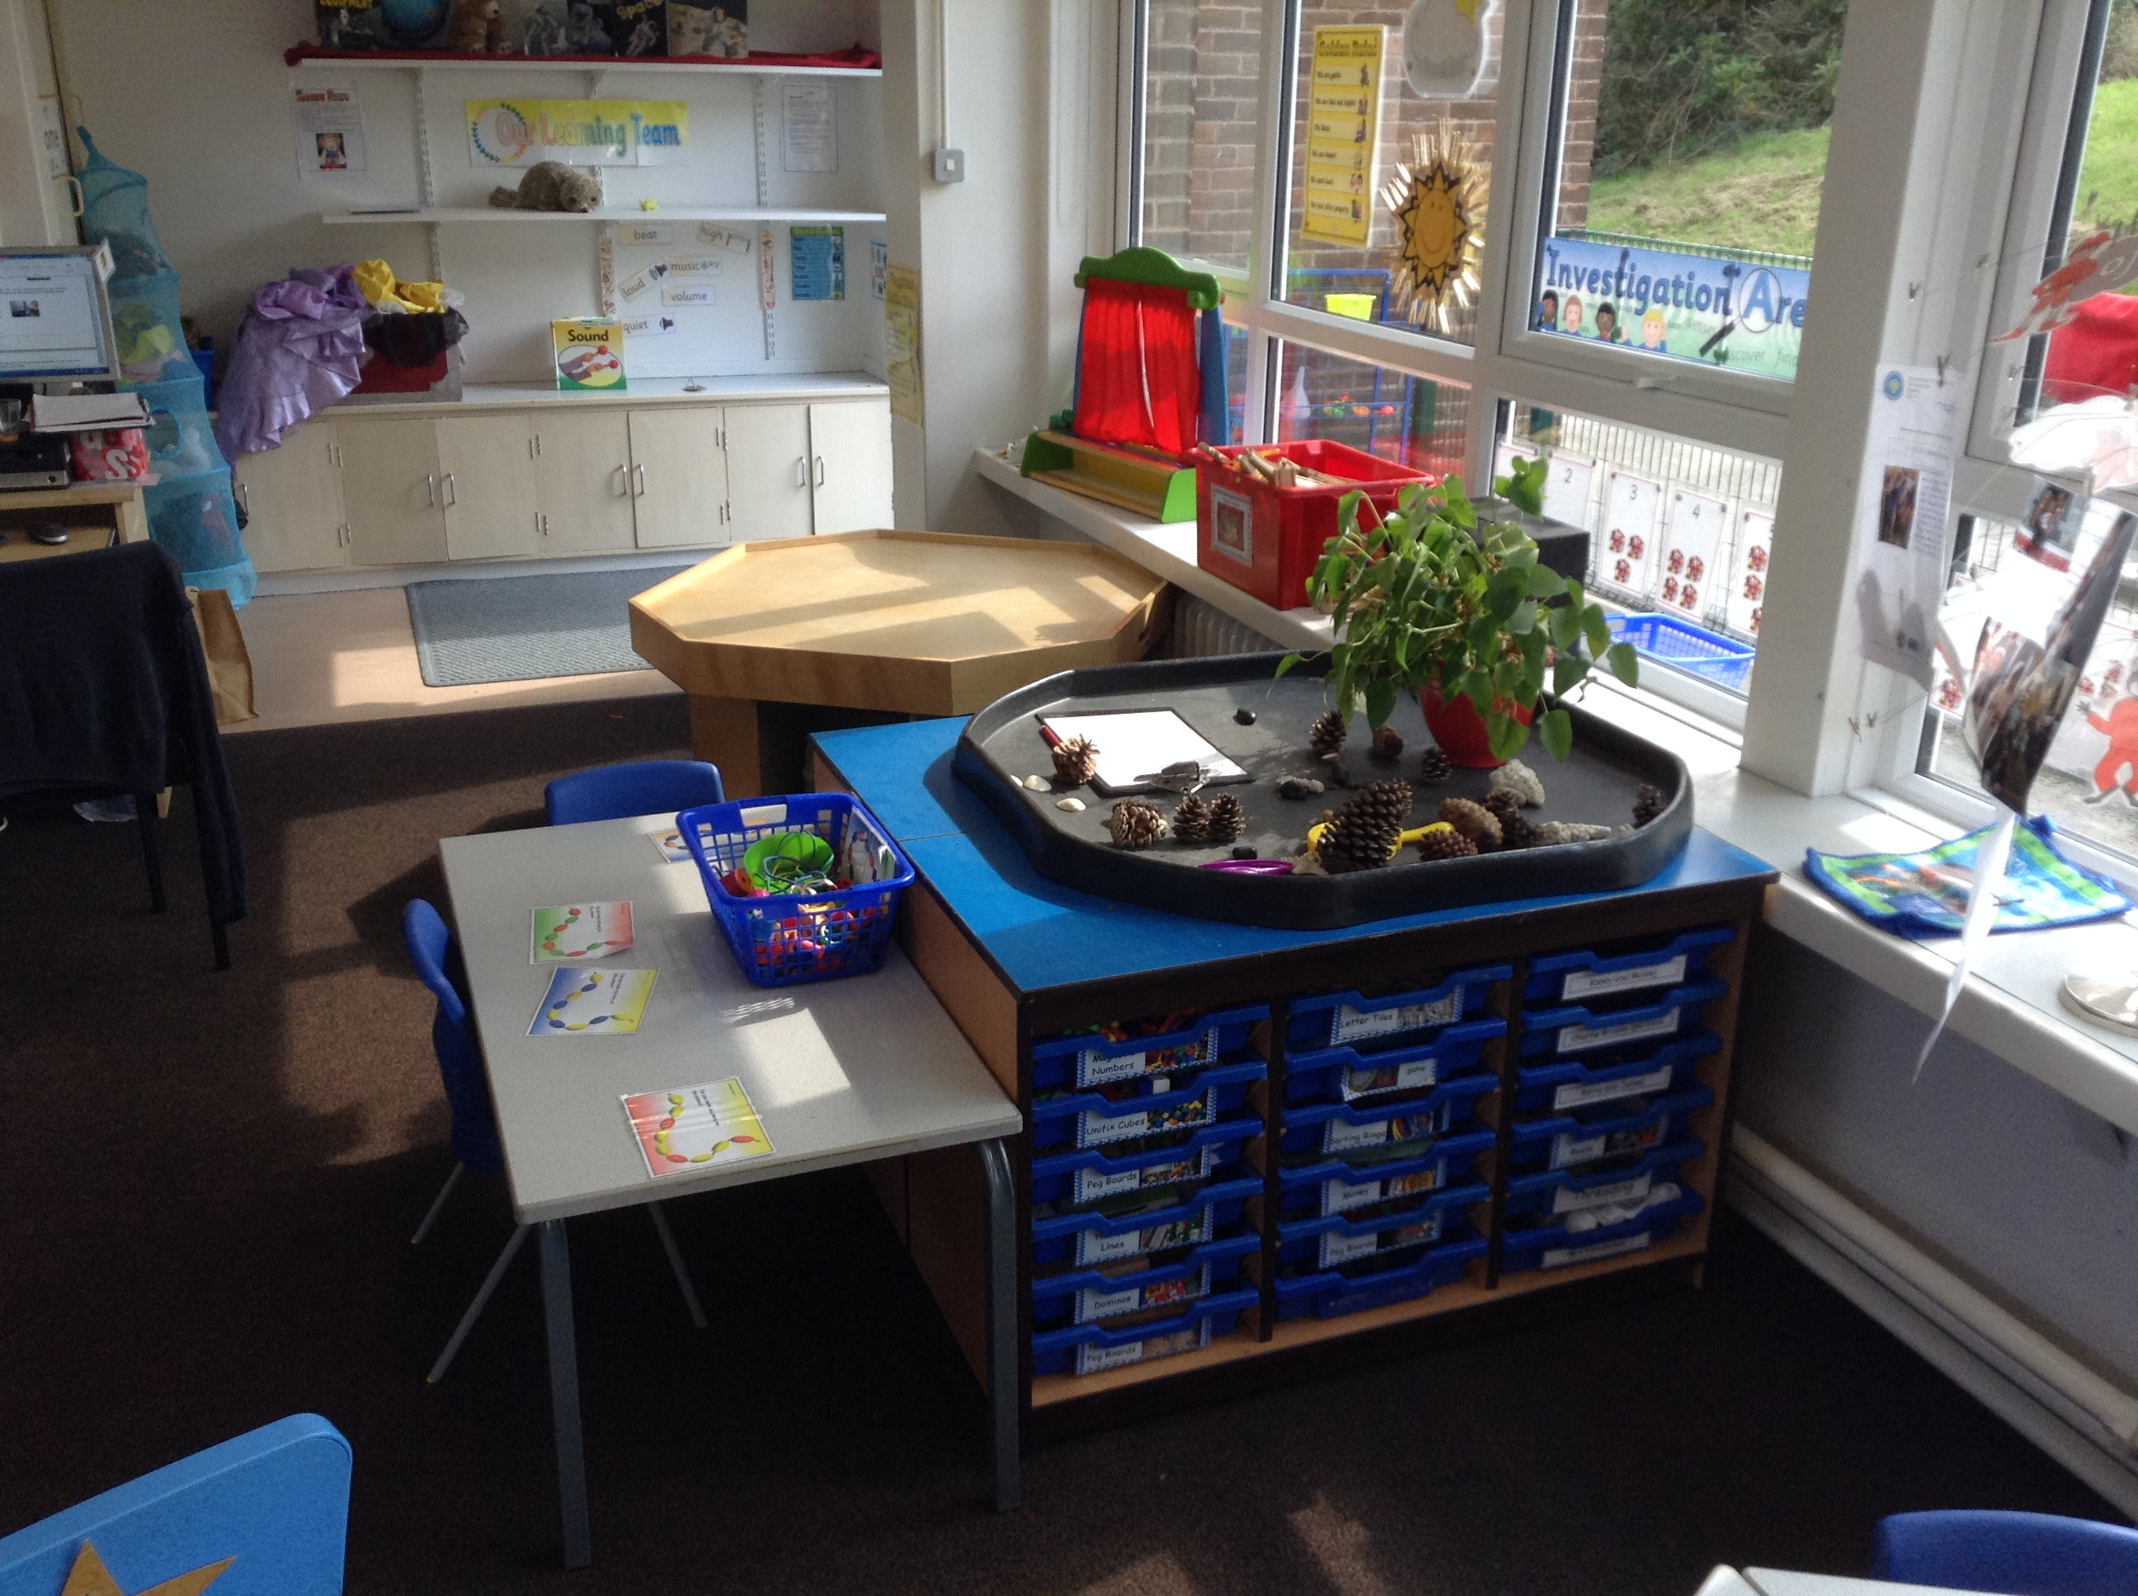

- The bell will ring at 8.45 and this is the time to tidy away and say good bye to your child with a hug, kiss and cuddle to ensure that you can smile and have a nice day. If separation is proving to be a challenge just let us know and one of us will come and assist you. If your child has been distressed we will phone you later that morning to let you know how they are doing.

- The children will sit with their class teacher on the carpet, ready to take the register and check that everyone has chosen a lovely lunch.

Helpful hints

- Mrs Hutchinson’s teaching days are Tuesday, Wednesday and Thursday. Miss Denton teaches on a Monday and Friday, but is in and around school all week.

- Snacks: We ask that you provide your child with a healthy snack for the afternoon (fruit, breadsticks, vegetable sticks, hard cheese). Snacks not taken home at the end of each day will be disposed of, to help keep our classroom smelling fresh. We ask that you label this snack, as 10 apples can all look the same!

- Water bottles: These should be provided on a daily basis please, to help your child stay hydrated, awake and ready to learn. Please can you refresh the contents each day. Water ONLY is allowed in school NO juice, as sugar stops you from thinking as well as you can!
If your child has a diagnosed medical condition that affects their fluid intake, please have a
chat with one of our team so we can help in every way.

- PE: We will be doing PE twice a week. On Tuesday PE will be inside and on Wednesday PE will be outside. Please make sure your child has a full PE kit in a named bag- dark shorts and white t-shirt (inside kit) and a warm track suit/joggers/hoodie and trainers/pumps (outside kit). Please ensure any earrings have been removed before school. Kits can be left on their peg for a few weeks before being taken home for freshening up.
Please can we ask that you write your child’s name in EVERYTHING, as 20 pairs of shorts all the same size and colour can all look the same. Oh it can be hard work sorting that lot out!!

- Book Bags: Please bring this to school every day and check for notes, letters and new books to share with your child. We will try to ensure that letters are only sent home on Fridays to make life easier for you. You are welcome to choose a book from our library and take it home. When you have enjoyed sharing it simply return it and select another one. As your child is given a reading book you are welcome to change it over the week. We only ask that you keep using the same colour band. We will talk with you more about this as the half term moves on.
- Wellies: Please bring to school a pair of labelled wellies in a carrier bag. Your child will be using them on a daily basis in our outdoor learning area and also each week for ‘Welly Wednesday.’ We suggest that you leave them on your child’s peg to save you bringing them in each day. less thing to think about!

- Uniform: We ask that you write your child’s name in each piece of uniform, including pants, vests and coats, so that lost clothing can be easily returned to your child. On Welly Wednesdays your child will probably get a bit messy with their outdoor learning, so they are welcome to come in their normal clothes (not school uniform). We ask that Welly Wednesday clothes are suitable for the outdoors; for example no party dresses. In our experience jeans tend to get wet and are hard to dry. Track suit bottoms are great and durable. This would be our recommendation.

If anybody is willing to spend a little time in the classroom to hear readers or work with the children, your help will be greatly appreciated. Please let us know if you are / think you might be interested.

And finally, if you have any queries, questions or concerns please do not hesitate to ask one of us. We are always more than willing to make the time after school to chat with you.

Many thanks,
Class 8 team

Mrs Hutchinson, Miss Denton and Miss Cowley




